Lab 05
Name: Azhar Soomro
CMS ID: 023-24-0521
Class: AI-B

Contents
Question 1: 3
Question 2: 4
Question 3: 5
Question 4: 6
Question 5: 7
Question 6: 8
Question 7: 9
Question 8: 10
Question 9: 11
Question 10: 12

Question 1:
Implement a class Car, that has the following characteristics: a) brandName, b) priceNew, which represents the price of the car when it was new, c) color d) odometer, which is milo meter shows number of milage travelled by car The class should have: A. A method getPriceAfterUse() which should return the price of the car after being used according to the following formula: B. A method updateMileage(double traveledDistance) that changes the current state of the car by increasing its milage, C. A method outputDetails() that will output to the screen all the information of the car, i.e., brand name, price new, price used, color, and odometer.
a. Create an object of type Car. b. Assign any valid values to the instance variables of the object created in ‘A’. c. Use the method getPriceAfterUse on the object created in ‘A’ then output the result to the screen. d. Use the method updateMilage on the object created in ‘A’ by passing a valid value. e. Do part ‘C’ again. f. Use the method outputDetails on the object created in ‘A’.

Code:
import java.util.Scanner;
class Q1TestCar{
public static void main(String aaaa[]) {
Scanner sc = new Scanner(System.in);
Car c1 = new Car("Toyota", 3000000, "White", 32000);
c1.getPriceAfterUse();
System.out.println("Price before use: " + c1.priceNew + "\nPrice After use: " + c1.priceNow);

System.out.print("\nEnter New Mileage: ");
double newMile = sc.nextInt();
c1.updateMileage(newMile);
c1.getPriceAfterUse();
System.out.println("Price After use: " + c1.priceNow);
c1.outputDetails();

}
}
class Car{
String brandName = null;
int priceNew = 0; //price of car when it was new
String color = null;
double odometer = 0.0; //mileage
double priceNow = 0;

Car(String brandName, int priceNew, String color, double odometer) {
this.brandName = brandName;
this.priceNew=priceNew;
this.color=color;
this.odometer=odometer;
}
void getPriceAfterUse() {
priceNow = priceNew * (1-(this.odometer/600000));
}
void updateMileage(double traveledDistance) {
this.odometer = traveledDistance;
}

void outputDetails() {
System.out.print("\nBrand name: " + brandName + "\nPrice when it was new: " + priceNew + "\nPrice now:" + priceNow + "\nColor: " + color + "Odometer: " + odometer);
}
}

Output:
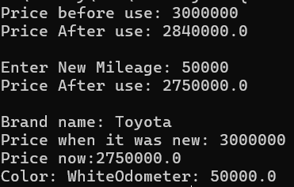

Question 2:
MyJava Coffee Outlet runs a catalog business. It sells only one type of coffee beans. The company sells the coffee in 2-lb bags only and the price of a single 2-lb bag is $5.50. When a customer places an order, the company ships the order in boxes. The boxes come in 3 sizes with 3 different costs:
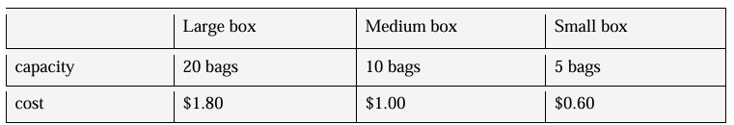
The order is shipped using the least number boxes. For example, the order of 52 bags will be shipped in 2 boxes: 2 large boxes, 1medium and 1 small. Develop an application that computes the total cost of an order

Code:
import java.util.Scanner;
class Q2ShipTest {
public static void main(String AAAAA[]) {
Scanner sc = new Scanner(System.in);
System.out.print("Enter number of bags: ");
int totalbags = sc.nextInt();
Ship obj = new Ship(totalbags);
obj.display();
}
}
class Ship {
int largeCap = 20;
int medCap = 10;
int smallCap = 5;
double largeCost = 1.8;
double medCost = 1.0;
double smallCost = 0.6;

int largeCounter, medCounter, smallCounter, totalbags;
Ship(int totalbags){
this.totalbags = totalbags;
calculate();
}
void calculate() {
int remainingbags = totalbags;
largeCounter = remainingbags / largeCap;
remainingbags = remainingbags % largeCap;

medCounter = remainingbags / medCap;
remainingbags = remainingbags % medCap;

smallCounter = remainingbags / smallCap;
remainingbags = remainingbags % smallCap;

if (remainingbags > 0)
smallCounter++;
}

double getboxCost() {
return (largeCounter*largeCap) + (medCounter*medCap) + (smallCounter*smallCap);
}

void display() {
System.out.println("Number of bags ordered: " + totalbags);
System.out.println("Cost of Order: $" + (totalbags * 5.5));
System.out.println(largeCounter + " Large - $" + (largeCounter * largeCost));
System.out.println(medCounter + " Medium - $" + (medCounter * medCost));
System.out.println(smallCounter + " Small - $" + (smallCounter * smallCost));
System.out.printf("\nYour total cost is: $ %.2f\n", ((totalbags * 5.5) + getboxCost()));
}
}

Output:
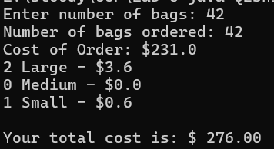

Question 3:
Rectangle class: Write a Java class called Rectangle with attributes width and height. Include methods to calculate the area and perimeter of the rectangle. Create two instances/ reference variables of the Rectangle class and: • Set Object’s instance variables using Scanner: set the values of the instance variables using the Scanner class. Set Object’s instance variables using JOptionPane: set the values instance variables using JOptionPane. • Call the Methods: Call both methods of area and perimeter and display the output.

Code:
import java.util.Scanner;
import javax.swing.JOptionPane;

class Rectangle {
double width, height;

Rectangle(double width, double height) {
this.width = width;
this.height = height;
}

double calculateArea() {
return width * height;
}

double calculatePerimeter() {
return 2 * (width + height);
}

void display() {
System.out.println("Width: " + width + ", Height: " + height);
System.out.println("Area: " + calculateArea());
System.out.println("Perimeter: " + calculatePerimeter());
}
}

public class Q3RectangleTest {
public static void main(String[] args) {
//scanner
Scanner sc = new Scanner(System.in);
System.out.print("Enter width for first rectangle: ");
double width1 = sc.nextDouble();
System.out.print("Enter height for first rectangle: ");
double height1 = sc.nextDouble();
//object 1
Rectangle r1 = new Rectangle(width1, height1);
r1.display();

//JOptionPane
double width2 = Double.parseDouble(JOptionPane.showInputDialog("Enter Width for Rectange 2:"));
double height2 = Double.parseDouble(JOptionPane.showInputDialog("Enter height for Rectange 2:"));
//object 2
Rectangle r2 = new Rectangle(width2, height2);
JOptionPane.showMessageDialog(null,
"Rectange Details:\nWidth: " + r2.width + ", Height: " + r2.height +
"\nArea: " + r2.calculateArea() + "\nPerimeter: " + r2.calculatePerimeter());
}
}

Output:
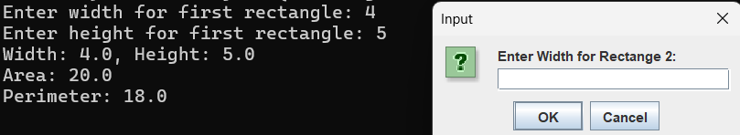
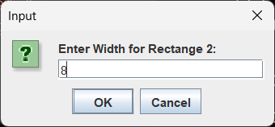 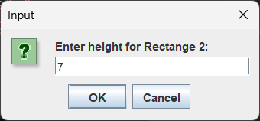
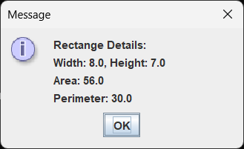

Question 4:
An array of Objects: In the practice exercise, you've already created a Student class and instantiated two objects of that class. Now, I'd like you to perform the following tasks: • An array of Student Objects: Create an array of Student Class with a size of 5. Setting Object Variables using Scanner: Use a loop to set the values of the object variables in the array using the Scanner class.

Code:
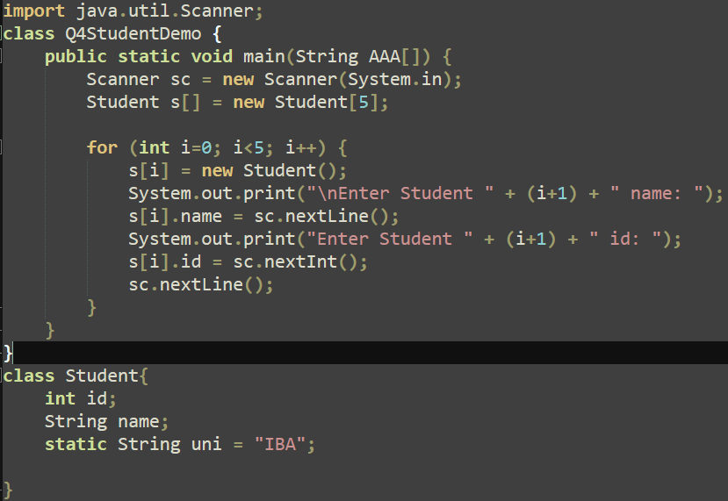

Output:
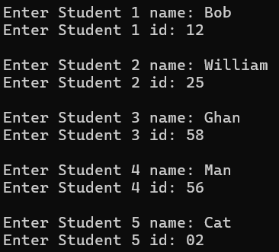

Question 5:
Create your version of Date class that includes three instance variables—a month (type int), a day (type int) and a year (type int). Provide a constructor that initializes the three instance variables and assumes that the values provided are correct. Write a test app named DateTest that demonstrates class Date’s capabilities.

Code:
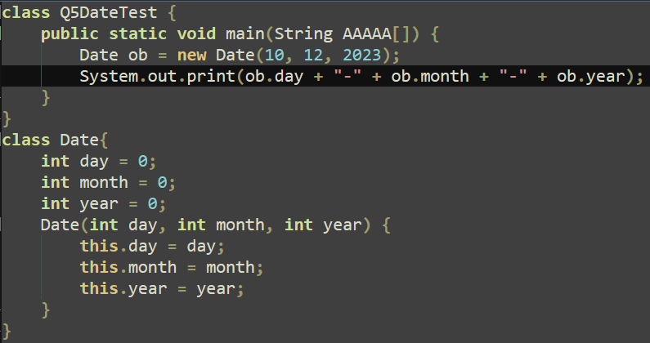

Output:

Question 6:
Write a program by creating an 'EmployeeInfo' class having the following methods and print the final salary. • 'collectInfo()' which takes the salary, number of hours of work per day of employee as parameter and sets the values of paramters • 'AddWork()' which adds $5 to salary of employee if the number of hours of work per day is more than 6 hours. • 'printFinalSalary()' That displays the final salary of the employee

Code:
import java.util.Scanner;
class EmployeeInfo {
double salary;
int hours;

void collectInfo(double salary, int hours) {
this.salary = salary;
this.hours = hours;
}

void AddWork() {
if (hours > 6) {
salary += 5;
}
}

void printFinalSalary() {
System.out.println("Final Salary: $" + salary);
}
}
class Q6EmployeeInfor {
public static void main(String AAAAA[]) {

Scanner sc = new Scanner(System.in);

EmployeeInfo emp = new EmployeeInfo();

System.out.print("Enter employee's salary: ");
double salary = sc.nextDouble();

System.out.print("Enter employee's working hours per day: ");
int hours = sc.nextInt();

emp.collectInfo(salary, hours);
emp.AddWork();

emp.printFinalSalary();
}
}

Output:
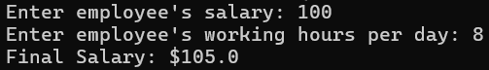
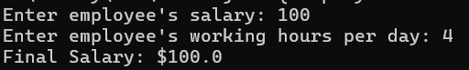

Question 7:
Exercise: Static Method: (LastDigit.java): Write a static method named findLastDigit that returns the last digit of an integer. For example, findLastDigit(3852) should return 2

Code:
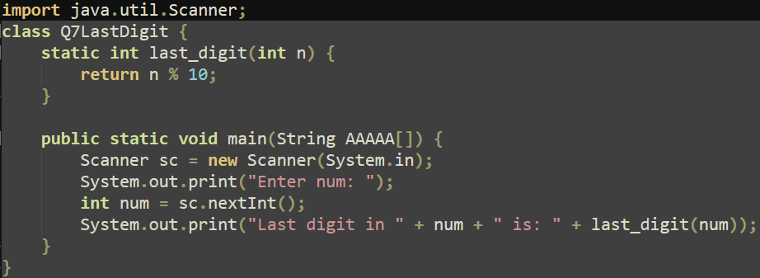

Output:
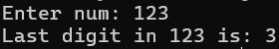

Question 8:
Create a class ArrayUtils that contains a static method for finding the maximum element in an array of integers. Method: findMaxElement Signature: public static int findMaxElement(int[] arr) Purpose: Returns the maximum element in the given array of integers.

Code:
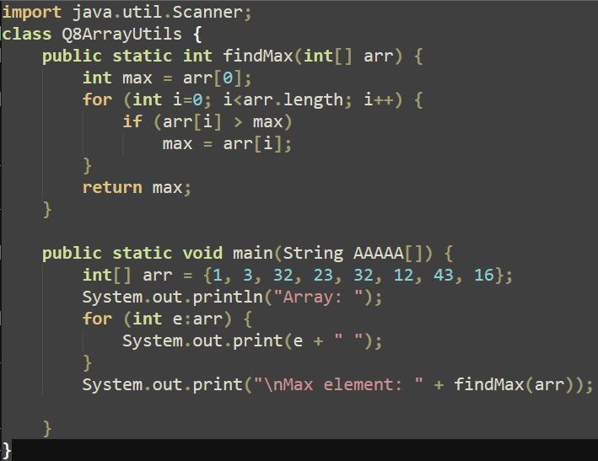

Output:
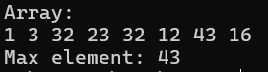

Question 9:
Exercise (FactorialDetector.java) Write a program that takes input from the user. It tells the factorial number of the input.

Code:
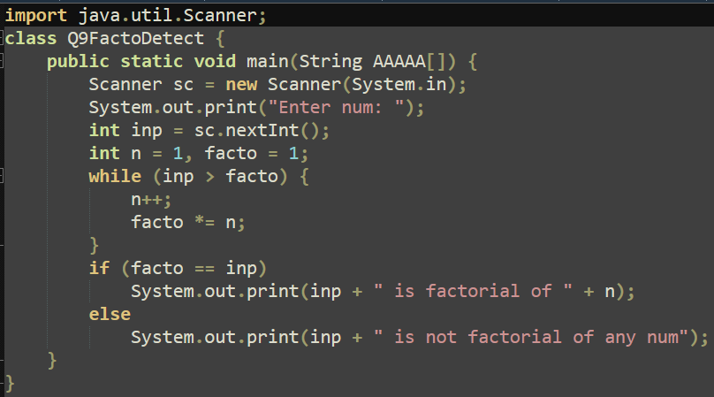

Output:
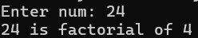

Question 10:
Exercise (Method Overloading) Write a program by creating class MethodOverloading that contains following methods • Computations (int length, int width). It takes length and width and displays Area of Rectangle. • Computations (String name, int age) it takes name, and age. Display name, and age. • Computations (double mass, double acceleration) It takes mass and acceleration and displays force. Code snippet example to call/invoke these methods in the main() function
Code:
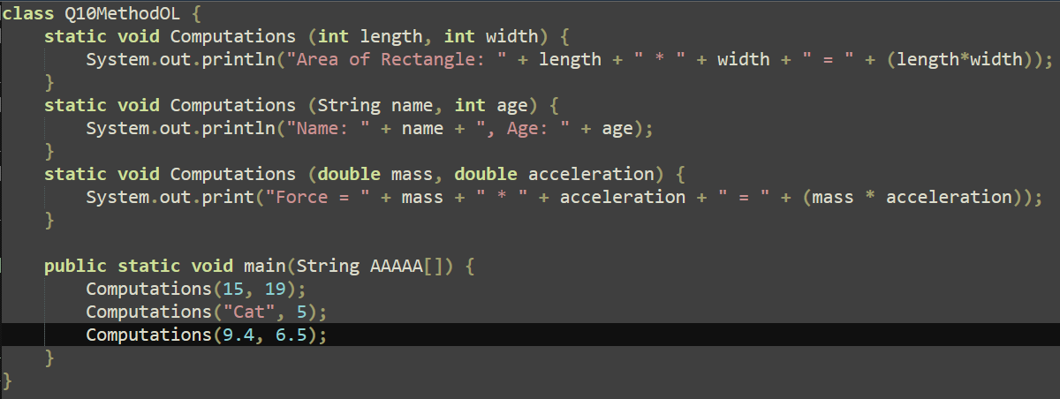
Output:
